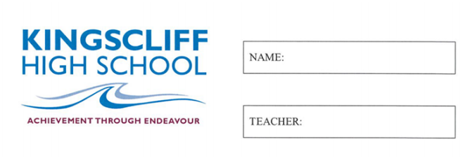
MATHEMATICS

Year 7

Yearly Exam

2026

Time allowed: One hour and 15 mins
5 mins reading time
Instructions  - Attempt all questions  - Show working where needed  - A calculator is NOT permitted |  | Sections and Marks  Part A (Multiple Choice) – 15 Marks  Part B (Calculations) – 32 Marks  Part C (Data and Probability) – 23 Marks

Part A

1. | What is the median value in a set of data  - The most often occurring value  - The middle value  - The average of all the values  - The difference between the highest and lowest scores
2. | What is the range in a set of data  - The most often occurring value  - The middle value  - The average of all the values  - The difference between the highest and lowest scores
3. | What order of operations do we follow?  - Addition, subtraction, brackets and then multiplication and division  - Brackets then multiplication or division and then addition or subtraction  - Always addition first  - Multiplication, division, addition, subtraction, then brackets
4. | What does descending order mean?  - No order  - Smallest to largest  - Largest to smallest  - Largest, smallest, largest, smallest
4. | What is the place value of the second decimal place e.g. 2.5437  - Tenths  - Thousandths  - Hundredths  - Ten Thousandths
5. | What does ${11}^{3}$ mean:  - 11+3  - 11x11x11x11x11  - 11x3  - 11x11x11
6. | What is a variable?  - A number that is added  - The number that is the answer  - A letter in place of a number
7. | What is the sum of the internal angles of a triangle?  - $100°$  - $180°$  - $270°$  - $360°$
8. | Circle ONE identifying feature of an isosceles triangle  - All sides have equal length  - 2 equal angles  - 2 equal sides  - 3 equal angles
9. | What does perimeter calculate:  - The liquid that fills a 3D shape  - The length of the outside of a shape  - A shape  - The amount of space that is covered by a shape
10. | Numbers to the left of zero on a number line are known as:  - Positive numbers  - Negative numbers  - Mixed numbers  - Sideways numbers
11. | What is the mean?  - Most common number  - Largest number minus the smallest number  - All the numbers added together and divided by how many you have  - Smallest number minus largest number
12. | The sample space for rolling a die is:  - 1,2,3,4,5,6  - 1,3,5  - 4  - 4 out of 6
13. | P(E) means ‘the probability of an event (E) occurring’  - True  - False
14. | An acute angle is:  - Less than 90 degrees  - More than 90 degrees  - Exactly 90 degrees  - Between 180 and 360 degrees
15. | Corresponding angles on parallel lines are:  - Supplementary  - Complementary  - Equal  - Opposite

Part B

1. | Calculate the missing angle and provide working out.  80$°$  x$°$  60$°$ | 2  marks
2. | Calculate the size of the external angle and provide working out.  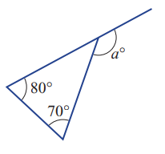 | 2 marks
3. | State True of False for each of the following: | 2 marks
  - $\frac{3}{4}=\frac{9}{12}$ | - $\frac{6}{11}=\frac{24}{33}$
4. | Calculate the following: | 2 marks
  - $0.2 ×3=$ | - $\frac{1}{3}×\frac{1}{2}$=
5. | Calculate the following:  - $-10+14=$  - $-5-4=$  - $8×(-3+5)=$ | 3  marks
6. | Convert into a mixed number:  - $\frac{3}{2}$  Convert to an improper fraction:  - $4\frac{1}{3}$ | 2 marks
7. |  | 2 marks
  Write an algebraic expression for each statement. Use $x$ to represent the number:
  i) 3 times the number
  ii) The difference between the number and 5
8. | If $a=4 b=3 and c=2$  Solve the following by substitution  - $a+b+c=$  - $ac+3=$ | 2 marks
9. | Simplify the following:  - $4d+2d=$  - $ab+2ab+3ab=$  - $10f+2-2f=$  - $3×3y=$ | 4 marks
10. | Calculate the following: | 5  marks
  i) $4+21=$
  ii) $-3+18=$
  iii) $22+6+18+4=$
  iv) $7×400=$
  v) $22×9=$
11. | Solve the following equations:  - $t+4=6$  - $g-6=12$  - $5k=30$  - $\frac{d}{4}=$3  - $2f+4=20$  - $\frac{r-3}{2}=$ 8 | 6 marks
Part C

12. | The following is a list of the amount of goals that Taj scored in each soccer match over the course of the season:  2 4 2 5 3 4 5 6 6 4 3 3  2 1 3 5 6 9 4 2 3 3 2 1  - Construct a dot plot from the above set of data  - How many games did Taj play in the season?  - What is the mode?  - What is the range?  - How many games did Taj score less than 4 goals?  - Is there an outlier and what is it? | 8 marks
13. | Observe the following set of data:  2, 3, 5, 2, 4, 1, 3, 5, 2  Calculate the following:  - The mean  - The median  - The mode  - The range  If 13 was added to the data set, what would be:  - The new median?  - The new mean? | 6 marks

14. | Observe the following graph and answer the below questions  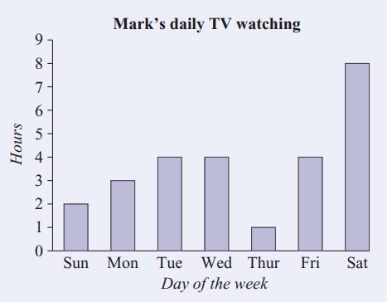  - How many hours of television were watched on Wednesday?  - How many hours of television were watched on Monday?  - On which day was the most television watched?  - How many hours of television were watched over the week shown?  - What fraction of Saturday was spent watching television? | 5 marks
15. | 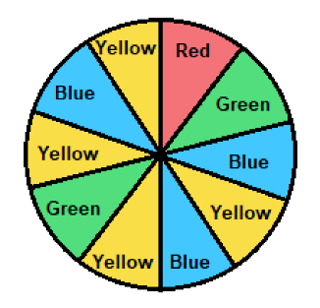  Observe the spinner above:  - List the sample space:  - What is the probability of spinning red?  - What is the complement of spinning blue? | 4 marks

